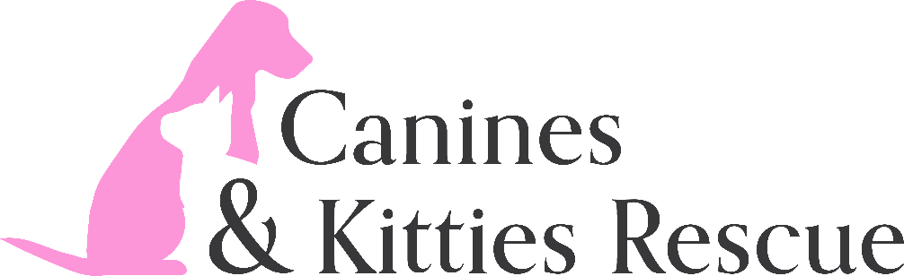

Animal Intake Policy

Canines & Kitties Resue intakes animals, primarily dogs and cats from Virginia In-State Shelters, Out-of-State Shelters, Owner Surrenders, and transfers from other Non-Profit Organizations. Animals may be any age or breed.

All animals are placed in foster homes and will be provided appropriate vetting including age-appropriate vaccines until adopted. Animals under 16 weeks of age will be held 7 days prior to the release of an adopter.

Owner surrenders shall be reviewed by the Executive Director and/or Director of Operations and may be considered on a case-by-case basis.

The final decision regarding the intake of an animal will be made by the Executive Director and/or Director of Operations. Criteria used for the intake of the animal may include the age, health, and temperament of the animal, available foster homes and Canines & Kitties financial situation.

