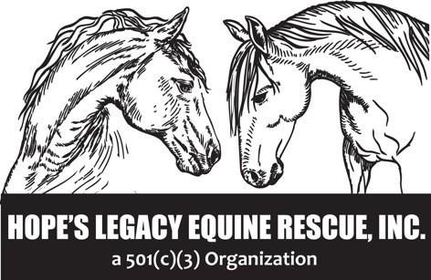
Rescue Operations- 000-09
Effective March 15, 2020
Revised December 14, 2021
Reviewed Jan 1, 2026

ANIMAL INTAKE PROCEDURE

Hope’s Legacy Equine Rescue (HLER) animal intake is restricted by the following:

- Animal type: any breed, age and ability/disability of horse, donkey, miniature horse, pony and mule.
- Animal Control or law enforcement agencies: who have seized equines, obtained owner surrender papers, or identified a stray equine with no known ownership.
- Owner Surrenders: HLER takes in equines directly from owners who willingly surrender their animal and sign surrender papers. An owner surrender form is included in Appendix E of this SOPP manual. Owner Surrenders are considered final.
- Safety Net: HLER also provides a safety net for all equines adopted from our Rescue. Any animal can be returned for any reason at any time.
- Strays: while rare, HLER will take in stray equines with no known ownership through Animal Control agencies.
- HLER does not purchase animals.

Hope’s Legacy Equine Rescue’s intake capacity is limited by the number of equines we have in house, the amount of fenced pasture we have available at Castle Rock Farm, and by the number of vetted foster farms we have available. HLER is ‘Full’ when the Rescue is at capacity.

We evaluate each animal individually and will make decisions regarding adoption, transfer, foster or euthanasia based on the animal and his or her ability to be safely re-homed.

Intake Decision-Making Process

Hope’s Legacy Equine Rescue carefully balances the amount of housing, number of volunteers, and income (donations) before taking in an animal. Additional intake cannot compromise the health of the existing rescue inhabitants or compromise the living conditions at Castle Rock Farm. Housing is calculated at 1.5 acres per full-size horse and .5 acres for a donkey, mule or miniature horse.

Animal Control or law enforcement agencies who have seized equines, or have obtained owner surrender papers, receive priority status at HLER. Most law enforcement agencies do not have housing for seized or surrendered equines. And if an animal is seized, generally they are most in need of our care.

Owner surrender intake is subjective. Intake decisions are made by the Executive Director. Prioritization for owner intakes include demonstrated need, such as the death of the caretaker of the animal; financial crisis; the owner can no longer physically care for the animal due to advanced age, illness or life-ending medical diagnosis; family crisis such as divorce; addiction; or any other criteria deemed credible to the Executive Director.

Owner Surrenders and Good Samaritan Surrenders are considered final. Good Samaritans take ownership from the original owner with the intention of surrendering her to HLER.
Completing the Intake Process:

Create a record for the equine. After creating a record for the animal, take photos of the animal. See animal record.

Check for tattoos and microchips.

Arrange for a vet exam. Depending on the condition of the equine, the vet exam can be immediate or within 2 weeks of arrival. If the equine is a stray, the vet examination does not take place until after the 5 day stray hold, unless it is an emergency.

