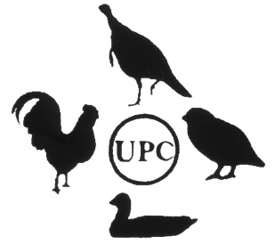**United Poultry Concerns, Inc.** P.O. Box 150, Machipongo, Virginia 23405-0150  
Phone: 757-678-7875 • Fax: 757-678-5070  
www.upc-online.org • info@upc-online.org

**United Poultry Concerns Intake Policy**

The purpose of our sanctuary on the Virginia Eastern Shore is to provide a home for chickens who already exist, rather than adding to the population and thus diminishing our capacity to adopt more birds. For this reason we do not allow our hens to hatch their eggs as they would otherwise do, given their association with the rescued roosters in our yard. All of our birds have been adopted from situations of abandonment or abuse, or else they were no longer wanted or able to be cared for by their previous owners.

Our sanctuary is a predator-proof fenced yard comprising 12,000 square feet that shades into tangled wooded areas filled with trees, bushes, vines, undergrowth and the soil chickens love to scratch in all year round. It also includes several smaller fenced enclosures with chicken-wire roofs, each with its own predator-proof house. Our chickens are kept safe from the raccoons, foxes, owls, possums and other predators inhabiting the woods and fields around us.

While we help people locate good sanctuary homes for chickens and other domestic fowl around the country, once we accept a bird into our sanctuary, that bird will live out his or her life with us and will not be sent to another home. All birds who come to our sanctuary have a permanent home with us. All birds who come to our sanctuary receive excellent veterinary care.

**UPC’s Intake Policy is as follows:**

*We educate people who contact us about finding a new home for a chicken or other domestic fowl to understand the limited resources available for responsible adoptions. We counsel people on how to keep their birds successfully, especially roosters, due to the number of roosters in need of homes and the difficulty placing them. We urge people to adopt chickens from animal shelters, and we urge people not to buy or breed chickens or any other birds, adding to the problem of unwanted birds.

*We prioritize chickens over other kinds of domestic fowl.

*We limit our sanctuary population to 100 birds or fewer.

*We provide immediate and subsequent veterinary care and treatment as needed.

*We worm each bird as soon as s/he is brought to our sanctuary.

*We try to adopt as many birds as we can into our sanctuary without straining our resources. Most years, we adopt around ten new birds per year.

We do not rely on a volunteer staff. We have three paid staff people. Our sanctuary assistants are well-qualified local people who understand and like chickens and other domestic fowl, who can spot a bird in the yard who needs possible medical attention, who are comfortable cleaning and refreshing our chicken houses and yard each day and ensuring that our birds always have clean straw bedding, fresh clean food and water every day.

As a 501c3 organization, we maintain our sanctuary entirely through donations from our members and supporters.

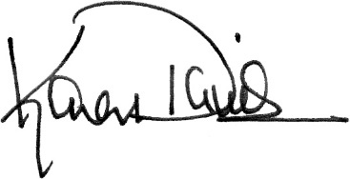

Karen Davis, PhD  
President  
United Poultry Concerns  
12325 Seaside Road, PO Box 150  
Machipongo, VA 23405  
Office: 757-678-7875  
Email: [Karen@UPC-online.org](mailto:Karen@UPC-online.org)

United Poultry Concerns is a 501(c)(3) nonprofit organization that promotes the   
compassionate and respectful treatment of domestic fowl. <http://www.upc-online.org>

*Federal ID: 52-1705678*