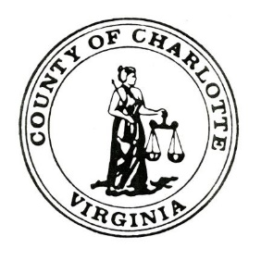
Charlotte County Animal Shelter
(434) 736-6041
alternate 434-542-5141
632 Dogwood Road
Charlotte Court House, Virginia 23923

Charlotte County Public Animal Shelter
Intake Policy

Decisions on Animal Intake are based on the following:

- Stray or Abandon
- Seized
- Bite Case Quarantine
- Owner Surrender
- Animals Received from another Virginia Releasing Agency
- Other

Animals that Charlotte County Animal Shelter does not take custody of:

- Wildlife

Guidelines for Intake Policy are derived from State Veterinarian Prescribed Format (Instructions) for Animal Custody Reports, as well as Animal Custody Record 3.1-796:105.B of the Code of Virginia.

